GENETICS
Definitions to be familiar with
- variation, gamete, zygote, fertilisation, chromosome, karyotype, gene, allele, dominant, recessive, homozygous, heterozygous, pure breeding, genotype, phenotype, trait, characteristic, phenotype ratio, Punnett square, pedigree chart, and semi-conservative.

Genetic code
- Cells are the ______________________ of all living organisms
- Chromosomes are stored in a cells _______________________
- Chromosomes are made of ________ and contain lots of genes
- Genes are the individual _____________ (“words”) that are the instructions for ________________ and maintaining a living cell
- One gene, for example, will code for ____________________, another for ____________________________________.
- We all have _______ genes for the same feature but we may have different versions of these features.
- Genes for _________________________________ of the same feature are called alleles.
- Everyone has ____________ alleles for eye colour – this may be one for blue and one for brown.
- As an example lets imagine a person having one of each from their parents.
- One of these will be dominant and will show through – and the person would have __________________ eyes.
- This person would have the ability to pass on either the brown-eyed ___________ or the blue-eyed __________ to each of their offspring.
- Each person has ____________ chromosomes arranged in ________ homologous pairs

Chromosomes and the Library
- The chromosomes in a cell’s _________________ are like a library – they contain a lot of ______________________________ – most of which is useful and essential.
- Each __________________ is like a chapter in a book.
- Each set of three bases (called a triplet) is like a _____________ in the chapter that refers to something particular.

- A ________________________ is a change in the sequence of bases and is like a ________________________ in the book that changes the meaning. Eg the hot cat could mutate to become
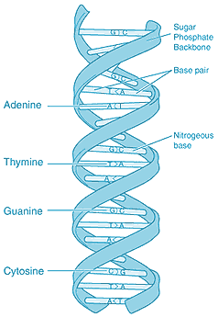
DNA structure
- DNA has a double helix shape (ie a ______ ___________________)
______________
- DNA is a ___________ of sugar, phosphate, and a nucleotide base
______________

Base pairing.
______________
The four bases always pair up with only one other base.
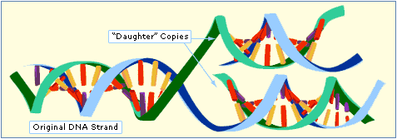
A to
______________
T to
C to
G to
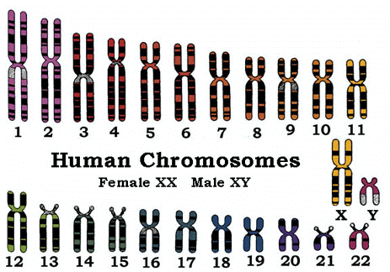
Human karyotype
A diagram which shows all the chromosomes in a cell arranged in their homologous pairs.
Obtained by photographing the chromosomes in the nucleus of a cell.
- Every person has __________ autosomes - non-sex chromosomes.
- Males have an ____________________________ sex chromosome.
- Females have ________________________ sex chromosomes

DNA replication
- DNA is unique as a molecule in being able to _________________ of itself in a process called DNA replication.
______________
______________
______________
- This happens just _______________________________ when new cells are made.
______________
The same chromosome under normal conditions
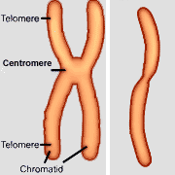
- When chromosomes are preparing to divide the DNA replicates itself into ______________________________ called chromatids.
______________
______________
Replicated chromosome

Steps in replication
- The double helix __________________ apart
- Enzymes ___________________ nucleotides according to the base pairing rules.
- The new chromosomes are __________________________ and are called sister chromatids

Cell division - mitosis
- Purpose - To make ________________________ for growth, repair and replacement.
- Occurs in ________________________________ (somatic cells)

Sequence of events in mitosis:
- Chromosomes ____________________________
- Chromosomes _____________________ along cell ‘equator’.
- Sister chromatids ________________________________ to opposite sides of cell by spindle fibres
- Cell ____________________ forms to separate daughter cells.

Two identical __________________ cells produced – in humans, each has __________ chromosomes containing ________ copies of all the genes – the same as the parent cell.
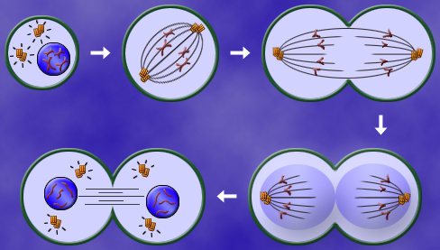
Cell division - meiosis
Purpose – to make ________________________ (sex cells) for reproduction.

Gametes = ___________________ (eggs) and _______________
Sperm are made in the ______________ while ova are made in the ___________________.
Sequence of events in meiosis:

- Chromosomes __________________________
- Homologous chromosomes ______________ across cell equator.
- Homologous chromosomes _________________________.
- _____________________________ forms to make separate cells.
- Chromosomes line up across cell _________________________.
- Sister ______________________________ separated
- New ________________________________________ forms.
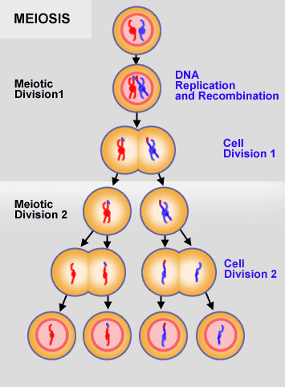
________ different ___________________________ cells produced – in humans, each has ____________ chromosomes – _____________________ the number of the parent cell.

Monohybrid crosses
- A ____________________________ gene is always expressed.
- A ________________________ gene will be hidden by a dominant gene and will only be expressed when ________________________.
- ____________________ letters represent dominant genes; _____________________________________ for recessive.
- In __________________, tongue rolling (R) is ________________ over non-tongue rolling (r).
- Homozygous dominant = ______________________________
- Homozygous recessive = ______________________________
- Heterozygous = _____________________________________

E.g. 1 In a family the parents could be:
- Father’s genotype = ________________
- Father’s phenotype = ___________________
- Mother’s genotype = _________________
- Mother’s phenotype = _________________________
- Father’s _____________________ contain R or r.
- Mother’s gametes can only contain _____________.
- A Punnett square is used to _________________________ the expected offspring’s genotype and phenotype ratios.

- Therefore __________ of the offspring are expected to be _______; __________ are expected to be ____________
- Therefore ___________ of the offspring should be able to roll their tongue; _____________ cannot.

E.g. 2 If D = dark hair and d = blonde hair, is it possible to get blonde children if the parents are DD and dd?

Therefore _________ offspring will be Dd which means all children will have ___________________. No children will have blonde hair.

